**IOT ANALYTICS IN SMART PARKING SYSTEM**

**INTRODUCTION :**

**OVERVIEW:**

In the recent years use of wireless technology is increasing for the need of upholding various sectors.In these years IOT groped most of industrial area specially automation and control.Smart parking system is one of the recent trends to provide better parking system.Due to the increasing number of vehicles on the road along with the mismanagement system of available parking space leads to the parking related problems as well as increased traffic congestion in urban areas.Thus it is highly required to develop an automated smart parking management system that would help the driver to find out some suitable parking space very spontaneously.Hence a prototype of internet of thing smart parking system is allotted.With this system we can detect the empty parking slots,entry and exit vehicles,automatic collecting of parking charges,estimation of each vehicle’s duration of parking lot usage etc.

**PURPOSE:**

By this project one can able to observe the detection of empty and filling parking slots.Automated gates at entry and exit of the parking area based on vehicle detection.Display at the entry of the vehicle owner with filled and empty slots information.

**LITERATURE SURVEY:**

**EXISTING PROBLEM:**

Due to increase in car ownership,it’s getting harder to find parking spots in densely populated areas.Searching for an available lot takes up potentially productive time,increases the number of cars circulating the roads,and introduces new challenges to the infrastructure.The vehicle owner is completely unknown about weather there is an empty parking slot is available or not .

**PROPOSED SOLUTION:**

By using IOT we can able to develop the application that shows the empty and filled parking slots and display at the entry of the gates and observe entry and exit of the vehicles.

**THEORETICAL ANALYSIS:**

**BLOCK DIAGRAM:-**

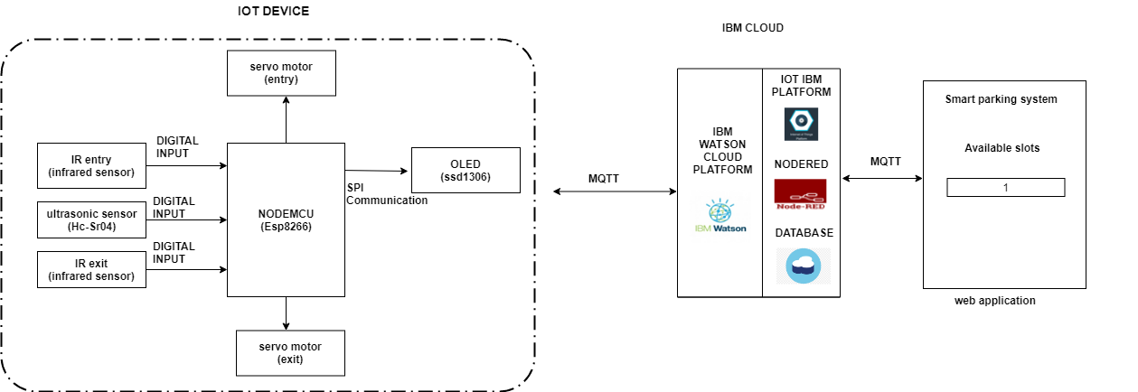

**Experiment investigation:**

Smart parking systems contains information about available parking spaces, process it and then place the car at a certain position. A prototype of the parking assistance system based on the proposed architecture was constructs. The adopted software and investigation of smart parking systems and their technology. The proposed project is smart parking system that delivers information to people finding a parking space online. The users can view various parking areas and choose the space from available slots

**FLOW CHART:**

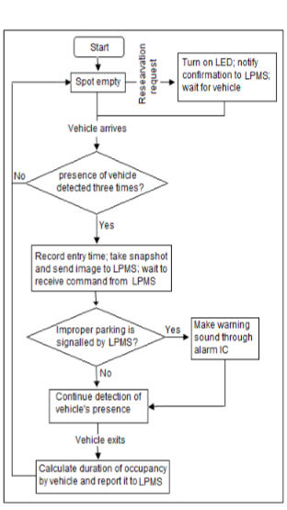

**SOFTWARE DESIGNING:**

In the software designing part create a IBM cloud platform. In this design the raspberry pi model is used .the software should be design by taking a random values and then sent to the IBM cloud services and then the data send to the mobile application which was developed using MIT app inventor.Here we use python language for coding,Node-Red,etc.

**Steps for software designing**

1.Setup Environment

2.Setup Hardware And Develop The Code

3.Building a Web App

**RESULT:**

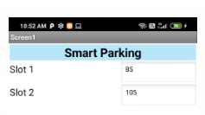

**ADVANTAGES AND DISADVANTAGES OF SMART PARKING SYSTEM**

**ADVANTAGES:-**

**Real-Time Data and Insights:-**For a car park operator or business – Smart Parking provides you with rich data-sets that can be used to identify trends, peak-times and other metrics that can be used in forecasting and reporting.

**Reduced Traffic:-**When a driver knows exactly where they need to go.it reduces idling and unnecessary driving – therefore optimises traffic flows in built-up areas.

**Convenience:-**It is difficult for searching available parking slots especially at peak times.The inability for someone to locate a parking space may result in lost custom or influence them to shop at alternative locations. The ability for a shopper or visitor to quickly identify a space reduces the friction and improves the overall experience. The convenience factor is of particular importance for spaces reserved for disabled drivers, public service or emergency vehicles.

**Safety:-**Decreased searching for spaces can reduce accidents by ensuring drivers maintain their attention rather than browsing for spaces or making rash manoeuvres.

**DISADVANTAGES:-**

* There is a greater construction cost per space
* Use of redundant systems will result in a greater cost
* It may be a bit confusion for unfamiliar users
* It is not required for high peak hour volume facilities
* There may be a fear of break down

**APPLICATIONS:-**

* The smart parking system can be implemented in
* Shopping malls
* Restaurants
* Theaters

**CONCLUSION:-**

* The project focuses implementatiom of vehicles parking place detection using internet of things
* The system benefits of smart parking go well beyond avoiding time wasting
* Developing a smart parking solutions with in a city solves the pollution problems
* Fuel saving
* Thus,the proposed system can detect the empty and filling parking slots and useful to avoid accidents,traffic jam and Time wasting issues.

**FUTURE SCOPE:-**

* The future of the smart parking system is expected to be significantly influenced by the arrival of automated vehicles.
* It increases more applications for more and different problems and it increases oppurtunities and decreases problems